Issues:

Git branch and saving

Create a folder on GitHub

Copy it’s URL link of HTTP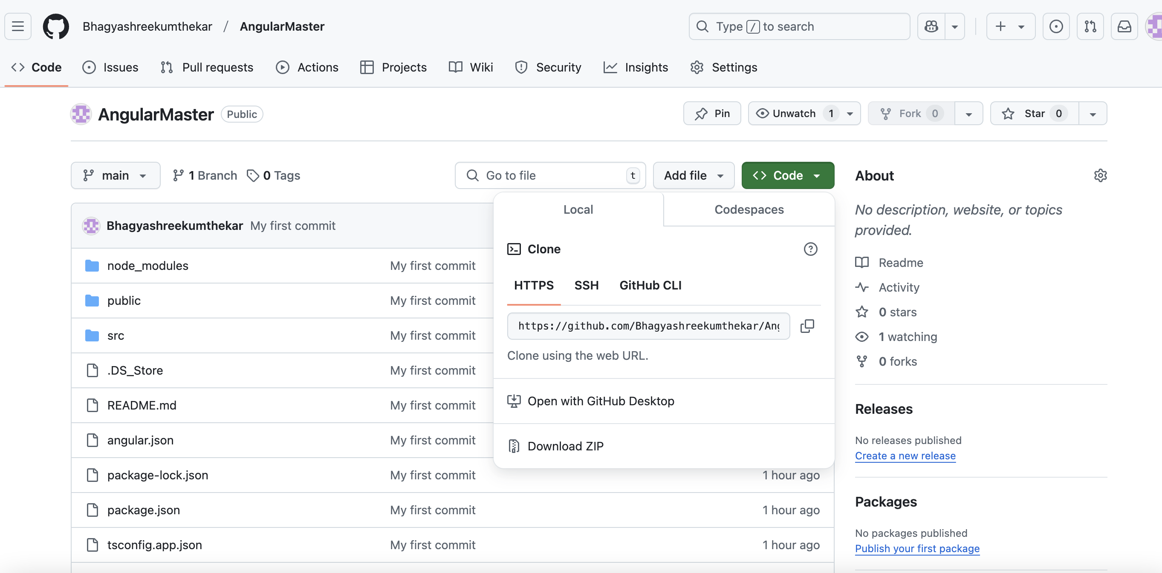

Create a local folder

Git clone copied _folder_url_link. —> you see the folder gets copied here

Git status

Git add .

Git commit -m “first commit”

Git push

Git status

Check:

If you are uploading one project on git ,after uploading you want to verify if all files uploaded or not

You can do git clone run using ng serve and check if your project is running.